
Folk of the Fairies’ Tree
Sculptor Ola Cohn, M.B.E (1892-1964)
and a Melbourne Icon
by Dr Barbara Lemon
The whole forest stirred to the rhythm of their dance, [the] trees joined in as well, swaying and whistling a lively tune to them… With the coming dawn, the Fairies and their Pets dance back to the tree – there to turn to wood – so staying throughout the day where-e’er they be.
Ola Cohn, The Fairies’ Tree, 1932
In the Fitzroy Gardens on the edge of the Melbourne city grid, half way between Clarendon and Lansdowne Streets, stands the severed trunk of what was once a giant red gum, gnarled and worn as an old hand. A cap of copper plating protects the site of amputation, while preservation rods pierce its midsection, slowly releasing boron and fluorine to prevent rot. It was into the natural contours of this trunk – then taller and veiled in ivy – that sculptor Ola Cohn chose to carve a wonderland of imps, fairies and native animals as a gift to the children of Melbourne. The work took three years, from 1931 to 1934. Since then her characters have performed their frozen dance for many generations. In all extremes of weather the eagle remains mid-flight; the fairy named Blossom shields her eyes from the sun; the Weeping Imp goes on clutching his foot as fat wooden tears fall from his face. [1, 2]
The Fairies’ Tree is likely Cohn’s best known work but it was a labour of love in the midst of an economic depression, unpaid and completed in her spare time for the public benefit: “A place of peace; a place that will make everyone happy, however sad and weary they may be at heart”. The sustained popularity of the tree and Cohn’s repeated appearances in newspapers and women’s magazines of the time, as well as publication of her two Fairies’ Tree books for children, may have detracted from the memory of her in her professional guise: as a highly accomplished artist who excelled in wood-carving, clay modelling and free-hand carving into stone; a graduate of the Royal College of Art, London; an esteemed student of sculptor Henry Moore; and a pioneer of modernist sculpture in Australia.
Ola Cohn was “a big flour bag of a woman, healthy as bread, strong as a millstone” in the affectionate words of writer and friend Barbara Blackman. She was something of an anomaly. Physically strong and financially independent, she worked hard to establish a career in a male-dominated field; she cared nothing for fashion, choosing to dress her robust figure comfortably in capes and smocks; she made her home from a converted livery stable cum motor garage; she ran life-drawing classes for American soldiers during World War Two (protecting their modesty with tea towels) just as happily as she ran pottery classes for kindergarten teachers in training. “Everything of Ola’s was, like her generous size, larger than life-size”, recalls Blackman, who also posed as an artists’ model. “The dais was higher, the combustion stove chunkier, the chairs wider, the cats huge”.
Cohn received her initial training in Bendigo, where she was born in 1892. Her mother Sarah Helen Snowball came from an Anglican establishment family with a strong presence in Melbourne political and social life. Her father Julius was born to Danish Jewish parents and co-owned the Cohn Bros. cider and cordial company in Bendigo, established by his father Moritz and Uncle Jacob. Carola (always called Ola) was the fourth of their six children and was home-schooled until she was twelve. She was shy, and happiest when surrounded by pets – cats, birds, mice, even silkworms – but as a young woman she felt the first stirrings of ambition: “Many are content to live, to marry, to die and be forgotten”, she wrote in her diary. “But that is not my idea. What would life be if we all lived for the sake of living and died because we all must die, with no name or memory to leave? I want to leave both name and memory behind.”
After years of studying drawing and sculpture at the Bendigo School of Mines with teacher Arthur Woodward, Cohn held her first exhibition at the family home in 1918 at the age of 26. She moved to Melbourne in 1920, after the death of her father, and enrolled at the Swinburne Technical College. In Melbourne she received mentorship from Web Gilbert and worked very briefly as assistant to British sculptor Paul Montford, though she found him arrogant and exploitative. Montford claimed she would learn more from him than by going abroad to study, but Cohn was feeling a need to underpin her growing reputation as a sculptor with broader technical training and a respected qualification.
At 33 she sailed for London with her sister Franziska, gaining entry to the Royal College of Art ahead of a 400-strong waiting list with an impressive entry exam piece. She would go on to win a scholarship there. The five years in London were enormously influential, personally and professionally. Cohn studied under the tutelage of Ernest Cole and Henry Moore, and was introduced to the work of Rodin, Maillol and Epstein. She travelled widely throughout Europe and Britain observing art and architecture. The training back home in anatomical, Greek-influenced sculpture – meticulously copied from life – seemed suddenly misguided as she watched Moore tackle a lump of stone: “With a few chalk marks here and there to suggest what he intends to carve, he whacks straight away at it, first knocking off its corners, and keeping his conception well in the centre of the block.” It was Moore who impressed upon her that any sculpture “abstract or otherwise… must contain that living force that makes the creation vibrate with life”. [3]
Cohn’s approach to her art was radicalised. She produced some of her most celebrated works at this time, including Head of a Virgin (1926), the bronze Comedy (1927) and the Portland stone carving of Mother Earth which today kneels before her buried ashes at her East Melbourne home. Her work was exhibited by the Royal Society of Artists, the Society of Women Artists, the Women’s International Art Club, Australia House and the Paris Salon. [4]
Back home the response was less laudatory. Cohn took up a studio at 9 Collins Street where she held a major exhibition of her London works in March 1931. It polarised the critics. The Bulletin journalist denounced her modernist style and questioned snidely “whether it is worthwhile chiselling and sawing these Madonnas suffering from elephantiasis out of such intractable material as wood, stone and marble”. Correspondents from the Herald and the Leader had a more positive response and Cohn’s talent was quickly recognised by fellow artists, cementing her place in the contemporary art world. Home Beautiful magazine praised her as “neither of the old school nor the new… imaginative, real and true to her art”. [5]
It was in London that Cohn had found her inspiration for the Fairies’ Tree. On a visit to Kensington Gardens she and two fellow students came across the Elfin Oak: “We forgot time, mist and cold as we walked round and round that wonderful tree which was carved into a fairyland… By the time I arrived back in Australia on the 4th of December 1930, I had built such a magnificent conception that my tree already lived in my imagination”. It was an imagination ripe for the task. Belief in spirit worlds was not uncommon at the time, and as a young woman Cohn had come to consider the presence of ghosts and fairies an ordinary part of everyday existence. She recounted with confidence the story of a peaceful afternoon spent in an English forest at the end of Autumn:
I was lying on a blanket of golden autumn leaves in the forest when I saw him on a tree branch above my head. He was a little wingless imp, with a green body and red feet. On his head was a red hat. He was busy with a little saw, cutting away at the bough on which he was balanced… As the last push severed the bough, it floated into space, carrying the fairy imp with it. He lifted his hat and waved goodbye to me as he drifted away.
Early in 1931 Cohn paid a visit to Dr. W. Kent Hughes, Chairman of the Parks and Gardens Committee for the Melbourne City Council, to discuss her proposal for the Fairies’ Tree. He was delighted with the idea and happy for her to begin at once. Of two possible trees in the Fitzroy Gardens, one bore the imprint of an aboriginal canoe and Cohn “would not touch it, thinking it sacred”. The other was perfect. It was May 1931 when she crossed the gardens from her Collins St studio and set to work with mallet and chisel, dressed in her trademark blue smock. [6]
Cohn began to give form to her characters, some of them allegorical (based on her family and pets), taking care to blend them with the natural growth patterns of the tree. First was the Koala with her baby on her back. Next came Sneaky Snake, then Stoutheart the hero on his bullfrog. There was the Thoughtful Imp, the Lizard, Sorcerer Spider, Reading Mother and a succession of animals including a rabbit, bandicoot, kangaroo, wombat, dingo, platypus, tortoise, snail, eagle, possum, emu, owl and lyrebird. The project quickly attracted public attention, but there were challenges that Cohn had not anticipated:
When first my mallet struck the tree, the bees showed their objection by stinging me on the eyelid for my impertinence. I realized that I must have deserved this treatment, having driven my chisel rather deeply into the gnarled trunk on a hollow spot just below the great tree’s dead heart... Soon the eye swelled alarmingly. From the Kiosk I borrowed a blue bag and dabbed it on the spot, giving me a rather theatrical appearance…
The mosquitos were my next annoyance; and also a very small insect which disguised itself by carrying dirt on its back… But these small mites were trivial when compared with humans. They distracted me by trying to draw me into conversations, some asking silly questions. One woman wanted to know how old the tree was; and when I told her about five or six hundred years she contradicted me by saying it could not be so, as Melbourne was only a hundred years old.
Back pain and cramps set in from prolonged periods of crouching, stooping and balancing on a ladder. Sun, wind and rain took turns to interfere. Vandals carved initials into the tree or stole parts of the carvings – the back of the tortoise was returned with a note by two small children after an advertisement was placed in the paper. “I did not then know of all the unhappiness and humiliation I would have to suffer in order to create a happy place”, Cohn later admitted, “but it is over now, and, as the years go by, the love I put into that tree will grow bigger and bigger, and expand to other corners of the earth”. [7, 8]
Already by 1933, photographs of the tree had found their way to newspapers as far away as Holland and Germany. Fox Movie-Tone filmed Cohn at work; she was profiled in Woman’s World, the Australian, Argus, Brisbane Courier, West Australian, and Sydney Morning Herald – often referred to as the Carving Lady or the Tree Trunk Sculptress. Children poked notes to the fairies into the notches of the trunk, or danced in circles around it making wishes. “They seemed to think I was an authority on fairies”, Cohn remarked in an interview for 3DB radio: “They’d ask me what they ate… did fairies play with animals or did they ever sleep?” Letters came in from children and parents across the country. Asked if she was she paid for the work, she replied: “Of course, but not in money… I receive a little payment every time I see children standing round the tree talking to the gnomes and elves and running their fingers over the carving”. [9]
It was Cohn’s ambition to invent an entirely Australian fairy lore: “Stoutheart will be our Peter Pan… and the Princess with the Smiling Lips our Wendy”. Her first children’s book, The Fairies’ Tree, was published in 1932 and followed a year later by More About the Fairies Tree. The books told the story of the fairies who had dwelled in the tree hundreds of years before. Driven out by the noise of warring tribes they roamed the land for centuries; meanwhile, their home was commandeered by an evil bunyip. On the advice of the Wise Magician they elected the brave Stoutheart to challenge the bunyip. With one touch of his magic bulrush wand he banished their foe to a cave where he was trapped forever more by the web of the greedy Sorcerer Spider. Both books were received by the (then) Princess Elizabeth in England, and the story dramatised by Marjorie McLeod. The play was performed by students of Adelaide’s Arts and Crafts School at Stow Hall on 20 July 1935, with Cohn as a guest of honour. [10]
In 1937 Cohn made the significant decision to purchase a large old livery stable at 41-43 Gipps Street, East Melbourne. After clearing out the cobblestone rooms, run down through years of neglect and made filthy by squatters, she found herself with comfortable living quarters; large spaces for exhibitions; a light and spacious studio; and a sprawling garden which was soon re-designed by Franziska Cohn. The door was always open to friends, children and curious passers-by and the studio became a hub for artists. Drawing and sculpting classes were held there as well as fundraising garden parties and meetings of artists’ societies including the Plastic Group, the Victorian Sculptors’ Society, the Sculptors’ Society of Australia, Melbourne Contemporary Artists and of course the Melbourne Society of Women Painters and Sculptors, of which Cohn was president for fourteen years. This was ‘Ola’s Home’ and became the Ola Cohn Centre when she bequeathed it to the Centre for Adult Education in 1964.
Between teaching, chairing societies, opening exhibitions, and receiving endless visitors Cohn completed several major commissions in the late 1930s. Two six-foot sandstone figures, Science and Humanity, were produced for the Hobart Hospital (1938); nineteen 6’ x 2’6” carved panels for the MLC building in Sydney depicting Australian industrial life based on illustrations by Murray Griffin (1939); and the remarkable seven-foot limestone Pioneer Woman carved freehand for the Pioneer Women’s Memorial Garden in Adelaide (1940). These were impressive works but Cohn’s skill was not always appreciated in a community still unaccustomed to the modernist style. The apparently bare-breasted Humanity caused uproar in the Tasmanian parliament, while some visitors to the Pioneer Woman did not bother to hide their contempt. They “thought my statue’s hands and feet too large, and not lady like and dainty. I had carved them so they would suggest the strength and power of a symbolic woman, one who could handle all situations and tread all soils with equanimity”. [11, 12]
In the 1940s and 50s Cohn returned to an establishment arm of sculpture with a focus on religion which was somewhat at odds with her lifelong interest in spiritualism and fantasy. She won the Catholic Centenary Prize of Melbourne in 1948 for Madonna and Child, and the Crouch Prize in 1952 for Abraham. Retirement commenced in earnest when she married her friend of many years, Herbert John Green, in 1953. In his days as government printer in the 1930s Green would reputedly bring his lunch to the Fitzroy Gardens to chat to Cohn and watch her carve her Fairies’ Tree, but he was then a married man and Cohn an independent woman who considered marriage an impediment to great artistic achievement. She was 61 when she finally married Green, by then a widower; he passed away just four years later. Cohn herself died in December 1964 at the age of 72, one month before she was awarded an MBE for her work in the service of art.
Ola Cohn re-visited her Fairies’ Tree to paint the carvings in 1956. It would be over twenty years before the Melbourne City Council authorised a major restoration program to address persistent problems of rot and weather damage, building on drainage work carried out around the base of the tree in 1971. After prolonged meetings, reports and debates between the City Architect, the CSIRO, the Victorian Sculptors’ Society, and the Parks, Gardens and Recreations Committee, it was decided to dig up the tree in 1977. Its roots were cut and treated, and the tree was mounted on a concrete block. Artist Ross Porritt repainted the carvings and plaster casts were taken in case of future damage. [13, 14]
Another twenty years passed before the tree was again marked for major conservation work; and not before the Council had received a series of anxious letters from members of the Victorian Sculptors’ Society, the Cohn family, and the general public. Some had brought their children to visit the tree to share childhood memories, and were dismayed to find the figures faded or rotting away. Given the exposed location of the tree, the prohibitive cost and inherently temporary nature of restoration work was a disincentive but in 1997 the Council awarded a tender to International Conservation Services Pty Ltd. Experts used fungicide to remove biological growth, with zinc octoate and tung oil to reduce weathering; they inserted preservation rods into the trunk; filled cracks and crevices; reconstructed damaged carvings based on the plaster casts taken in the 1970s; and painted the carvings in acrylic paint, using forensic analysis of paint scrapings to match Cohn’s original colour scheme. The work was repeated in 2005.
The Fairies’ Tree still stands; it is still loved by children and remembered by their parents and grandparents; the notches in its trunk still hold a collection of scribbled letters. Yet few would know its creator. Cohn herself once remarked that “fame which lives through artists’ lives only to die with their passing may have been as disastrous to them as neglect”. Here is an artist who deserves to be remembered not only for her extraordinary gift to children but for her important contribution to contemporary sculpture and to Australian art. Says art historian Juliette Peers:
We can never take away from her that positioning, that she was the first person to really present the sort of sculpture that showed… different values, these non-Greek values in sculpture, this return to carving, this interest in earlier forms of art or non-Western forms of sculptural expression. And that’s something that the whole of contemporary sculpture today is still indebted to, [that] first very courageous step she made. [15]
In her early 50s Cohn penned an autobiography, Me in the Making. At an unwieldy 150,000 words it was never published, but perhaps the real essence of Ola Cohn can be found on its first page just above her dedication to “my best friend, John”. These same words she carved into a wooden plaque for her studio:

A piece of stone which seems to have no life
A heavy hammer and some tools as well
Then give me space and light and air to breathe
With no tormenting company round about,
That I may try and carve into that stone
Expression of the vital force of life

This and all otherwise unattributed quotes from Cohn come from her unpublished autobiographical manuscript Me in the Making, Papers of Ola Cohn, MS 8506, Box 1023, State Library of Victoria
Barbara Blackman, Glass After Glass: Autobiographical Reflections, Penguin Books, Ringwood, 1997
The Bulletin, March 1931, clipping contained within the papers of Ola Cohn
Walter Jago, ‘Ola Cohn at work: her contribution to Australian architecture’, Home Beautiful, September 1939
‘They believe in fairies’, Australasian Post, 14 February 1957
The first book was published by H.Tatlock Miller at the Book Nook, Geelong; the second was self-published by Cohn
International Conservation Services Pty Ltd, ‘Treatment Report: Fairies Tree: Fitzroy Gardens, Melbourne’, August 1997 (Melbourne City Council archives)
Various of Cohn’s sculptures have been purchased by the Australian National Gallery, the National Gallery of Victoria, the Art Gallery of South Australia, the Queensland Art Gallery, University of Queensland Art Museum, University of Melbourne Gallery, and the Art Galleries of Bendigo, Ballarat and Castlemaine.
From an interview with Juliette Peers, art historian, quoted in ‘The Word in the Stone: Sculptor Ola Cohn’, Hindsight, ABC Radio National, September 2008 (produced by Barbara Lemon) LIST OF ILLUSTRATIONS IMAGE 1: 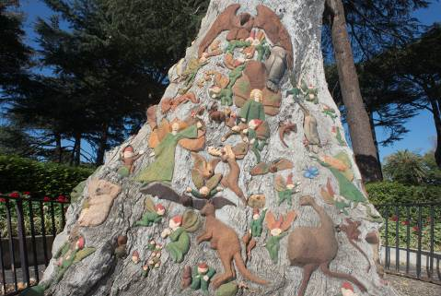 “With the coming dawn, the Fairies and their Pets dance back to the tree – there to turn to wood”. Photograph by Louis Porter, 2013. IMAGE 2: 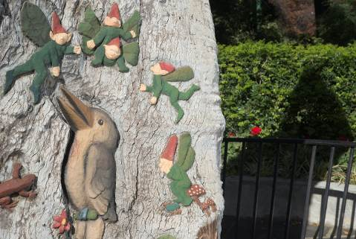 The Kookaburra and the Weeping Imp. Photograph by Louis Porter, 2013. IMAGE 3: 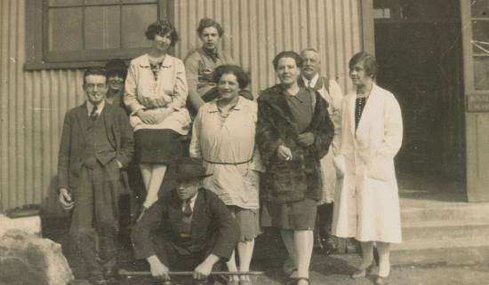 Ola Cohn (centre) with her sister Franziska Cohn (at right in fur coat) and fellow students at the Royal College of Art, London c.1929. Australian Manuscripts Collection, State Library of Victoria, MS 8506, Box 1027/2. IMAGE 4: 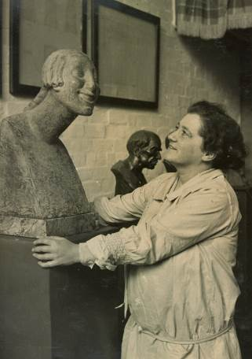 A young Ola admires her bronze Comedy (1927), which she described as “an abstract noun – sexless, yet with the force of the unreal, vibrating with life”. It was purchased by Queensland University. Australian Manuscripts Collection, State Library of Victoria, MS 8506, Box 1028/2. IMAGE 5: 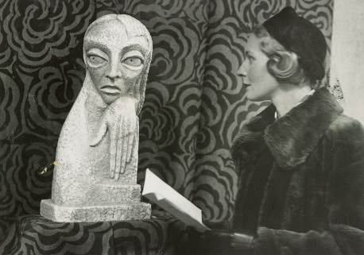 A visitor to one of Cohn’s exhibitions (date unknown) inspects her sculpture, Haunted. “A composition I had conceived of a spook or lost soul, terrified of its own peculiar being. When seeing it, Rupert Bunny remarked ‘It made one feel one’s own destiny’.” Australian Manuscripts Collection, State Library of Victoria, MS 8506, Box 1028/2. IMAGE 6: 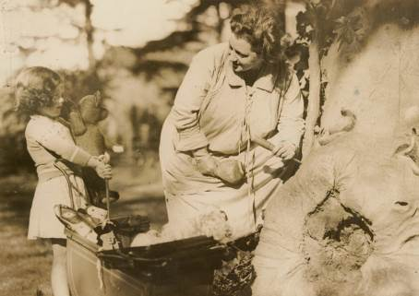 Cohn chats with a young visitor at the Fairies’ Tree, c. 1931. Australian Manuscripts Collection, State Library of Victoria, MS 8506, Box 1029/1. IMAGE 7: 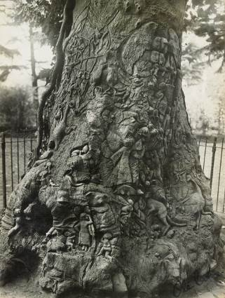 A close up of the carvings as they were in the 1930s. Australian Manuscripts Collection, State Library of Victoria, MS 8506, Box 1029/1. IMAGE 8: 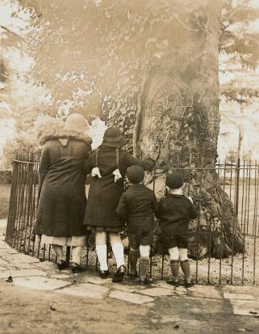 A family stops to admire the tree c.1934. Australian Manuscripts Collection, State Library of Victoria, MS 8506, Box 1029/1. IMAGE 9: 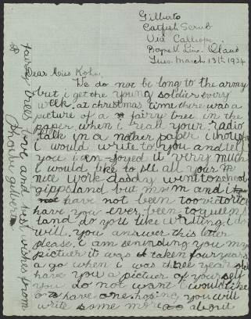 Cohn received letters from children around Australia, like this one from 7-year-old Phoebe Gilberto in Catfish Scrub, Queensland. Australian Manuscripts Collection, State Library of Victoria, MS 8506, Box 1026/4. IMAGE 10: 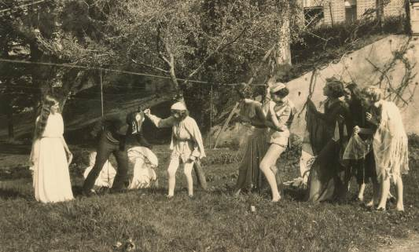 Students of the Arts and Crafts School in Adelaide perform Marjorie McLeod’s theatrical adaptation of the Fairies’ Tree story in 1935. Students made their costumes by hand: the bunyip can be seen here in a toothy mask; the Princess with the Smiling Lips wore a gown of rose-coloured chiffon while her attendant fairies wore woodland costumes of green and blue. Australian Manuscripts Collection, State Library of Victoria, MS 8506, Box 1028/3. IMAGE 11: 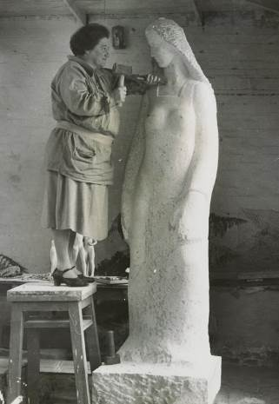 Ola looks her seven-foot limestone Pioneer Woman in the eye, c.1939. “The Pioneer Woman started to emerge from the stone, with an expression of calmness and dignity. I looked at her and felt as Galatea must have felt when he saw a living form coming to life under his touch”. Australian Manuscripts Collection, State Library of Victoria, MS 8506, Box 1029/2. IMAGE 12: 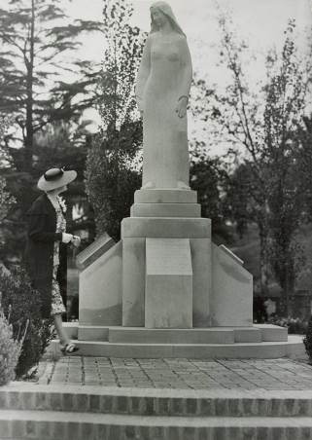 Cohn’s statue of the Pioneer Woman (1940) stands tall on its granite podium in the Pioneer Women’s Memorial Garden, Adelaide. “My statue is not the image of a mere mortal, but a spirit of womanhood capable of giving birth to a nation… I gowned her in a simple manner representing no period, as she must not date. She must live on as the spirit of the pioneer woman of all time.” Australian Manuscripts Collection, State Library of Victoria, MS 8506, Box 1029/2. IMAGE 13: 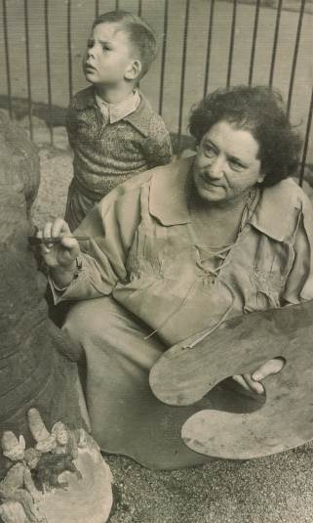 Cohn is supervised by a discerning visitor as she paints her Fairies’ Tree figures in 1956. Australian Manuscripts Collection, State Library of Victoria, MS 8506, Box 1029/1. IMAGE 14: 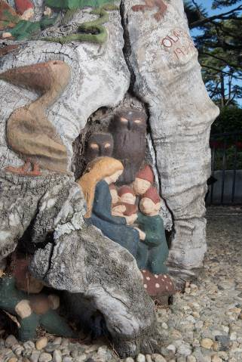 The Reading Mother with an attentive crowd; and below her, the Wise Magician and his crystal ball. Photograph by Louis Porter, 2013. IMAGE 15: 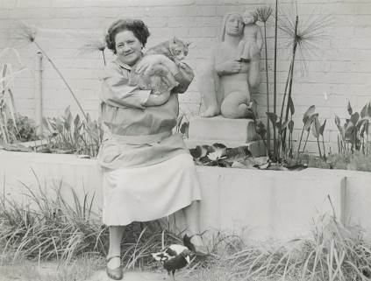 Cohn poses in her garden with beloved cat Ginger and magpie Margu. The pond is now a garden bed and Cohn’s ashes buried at the feet of her statue, Mother Earth. Australian Manuscripts Collection, State Library of Victoria, MS 8506, Box 1029/4. All images from the Australian Manuscripts Collection, State Library of Victoria, are re-produced with the permission of the Centre for Adult Education.

