I’m just passing through
by Nikki Lam
We are in a queue to a dumplings house in Chinatown. I am not 100% sure why we would come here as their dumplings are half as good as the place around the corner but they charge twice as much. Everybody knows that the restaurant runs a ‘pathway program’ for Chinese university students who want to get a residency. They get paid half of minimum wage. But I guess the group I’m with tonight is not everybody.
My phone pings.
‘what are you doing tonight? We are out for all-you-can-eat sushi in Mong Kok. Miss you.’ It’s a message from Apple.
‘Some shit Chinese restaurant in Chinatown’
‘They are all terrible! For gwai lo only!!!’ She added with a smily poo emoji, probably recalling that time she visited me in Melbourne in the middle of winter.
‘The food is worse here I promise. Nothing but fish and chips. But you are at least out with your friends? I am all alone,’ Kelvin finished the text with a sweat emoji.
Kelvin sends back a GIF with a sloth struggling to cross the road in the rain.
‘LOL,’Apple replies, ‘I still don’t know why either of you had to leave. This city is suffocating without you,’
‘There is no future here, only delicious food. I want to leave too…

—

Someone taps me on my shoulder. I look up. Ben’s slick smile takes over my view. He addresses the group and says something about how his ex-girlfriend took him to this dumplings place. She was Asian, according to Ben. I can’t help but notice his freckles under the neon sign of the restaurant. His red hair and peppy outfit makes him look like some tech startup entrepreneur or a hip architect from a blog.
His skin is so pale and delicate, catching the pink light, almost gleaming, like a screen.
He must have noticed my stare at his face. The same stare I have when I am looking at my phone.
I think he just winked at me. Or winked at my direction at least. I think I must be blushing a little as I can feel the blood gushing towards my neck.
My phone pings again. Perfect timing for a distraction.
I am catching up on the thread. They went from politics back to dating.
‘Is cute boy there tonight?’
‘I think he likes “Asians”,’ I reply.
Kelvin sends in three peach emojis and says, ‘THEY ALL DO,’ then finishes the sentence with a smirk.
‘Is that a good thing?’

—

After dinner, Samatha asked the waitress to take a photo of our group. Ben jumped off his chair and huddled next to me. He puts one arm around my shoulder and puts up the other hand in a victory sign for the photo. His hairy arm is resting across my neck. I can smell his deodorant.

I send off the photo.
‘Oooooh cute! He definitely likes you la… I don’t think I’ve seen a white boy does victory sign for photos before though,’ Apple adds.
‘Maybe I have only dated Chinese men, but his hairiness makes me feel weird,’
‘Like a tingling sensation? Like excitement?’ Kelvin likes to torment me over texts.
‘Gosh are you wasting all that food?’ There were plates of half-eaten dumplings in the photo.
‘We’re going for a drink now. Brb’
‘Have fuuuuuuuun!’ Kelvin sends off with an eggplant emoji. Apple sends me a video of herself sucking up a fresh oyster, ‘Have a delicious night!’
The image was hilariously seductive.

‘So what are your plans after this degree?’ Ben asks as we sit down onto a crimson velvety couch.
The light is so dim in here I can’t tell if the couch is clean. I swipe my hand across the seat and place my bag on it. ‘Not putting that on the floor? You are so Asian,’ Ben chuckled as he took a slip from his pint.
I’m not sure what to make of that comment. The floor is full of E. coli and particularly in this bar, my shoes are literally sticking to the floor. I just keep smiling at him, ‘I’m planning to stay in Australia for a while, if I can. It took me a while to make the move, so I probably won’t move back, not straight away. Our degree should give me some extra points when I apply to become a permanent resident.’
‘Why did you come to Melbourne? There is not much going on here. I took a gap year and travelled around the world before I started this course… Since then I’ve just been working and studying. I can’t believe I haven’t travelled for years. Travelling really is the only way to enrich your experience.’
If you haven’t realised being in Melbourne is living abroad for me.
‘Where would you rather be instead?’ I ask.
‘I don’t know… New York? London? The world is my oyster really.’
‘Why?’
Ben tells me how ultimately he just wants to be in a city where ‘stuff happens’, where there is night life, where there is business day and night, where you can rise above suburban life. He tells me about the dream of living in an apartment block in downtown New York, where there is noise when you sleep.
I try to interject my thoughts on light pollution in cities. But by this point he is explaining how gentrification destroys a city’s unique culture and that suburban life is the ultimate conservative life.
I go quiet because I can’t find a polite way to respond to this. Kelvin would have challenged him head-on, I think to myself.
I would do anything to live in a house in a quiet suburb. An actual house! With a backyard! Why on earth would he want to trade that off with a shoebox apartment probably infested with cockroaches? Why would you want to move somewhere where you have to work 70 hours a week just to feed yourself? Also, does he even know what it is like to have to wear earplugs to bed every night?
Why, when you have a choice, you would do such a thing to yourself?

Ben goes on about his dream but I’m drifting off. I just smile and nod and try not to roll my eyes. I do not understand how I could be attracted to someone and be puzzled by his dreams at the same time.
Across the dance floor there is a floor-to-ceiling window where I can see the harbour. Dots of lights are sprinkling across the highway from one end to the other. Docked boats and yachts sitting in silence, gently swaying in the early Autumn breeze. I am reminded of somewhere I know so well.
I take out my phone again. Eight unread messages from Apple and Kelvin.
‘I don’t think cute boy know much about life outside of North Fitzroy,’ I typed very quickly and then realised my friends did not understand the geo-cultural significance of North Fitzroy. ‘It’s like… the equivalent of Shoreditch in London and, probably Sai Ying Pun in Hong Kong.’ But not really, they are not really the same but anyway that is a close enough reference.
‘Pretty people rarely do? He is cute AF! You’d never find a guy like that here,’ Apple added.
‘He’s cute alright but he is not my type,’ Kelvin says.
Ben probably could tell that I am distracted. Can he see that I am a bit disappointed too? I hope not. He offers me another drink.

—

I am on the dance floor with Samatha and her new friends whose names I cannot pronounce. I can’t quite remember what I said but Ben has been avoiding my eye contact for the last hour.
I think I have had a bit too much to drink. Samatha’s long blonde hair is flying on the dance floor in changing colours.
We are taking a selfie when Ben says goodbye. I can smell my own sweat. The scent reminds me of that photo of Apple sucking up an oyster and I burst out in laughter.
‘I’m taking off, have a fun night!’ The music is so loud that he is almost yelling. He gives Samatha a hug and waves at me. I see three images of Ben.
‘I should probably go too,’ as I reach for a glass of water on our table, ‘I’ve had way too much to drink.’
Samatha is giving me a really big hug, ‘Babe I’ll see you on Monday? Text me when you get home safely. Love you.’ I kiss her on the cheek.
I am on the street but Ben seems to have vanished already. I guess I have offended him somehow.
I get out my phone while waiting for an Uber. I pondered whether or not I should sit on the kerb while I wait, but decided that I did not want E. coli on my bottom. There is nowhere to lean against so I decided to squat.
‘Why do gwai lo love dumplings so much?’ Apple says. The conversation has turned back to food. ‘It’s like, they can’t even tell the difference between wontons, dumplings and xiao long baos,’
‘And don’t get me started on the bao trend!’ Kelvin sent multiple angry emojis, ‘Bao that looks like a taco is not a fucking bao. They love dumplings because it’s the only thing they can understand and remember.’
I think I’m a bit too drunk for this conversation. So I send an emoji of a noodle box and fortune cookie and wrote, ‘and this. LOL’
‘Ni Haooooooo…’ some group of white men is yelling across the road.
I didn’t make a move. No eye contact, nothing. It happens every now and then so I learned to ignore it.
I don’t even speak Mandarin.
I took a selfie to show Apple and Kelvin how drunk I am. I pouted for the photo.
‘And someone just yelled Ni Hao across the road! WTF.’
‘Well but you are squatting…’ Kelvin added a crying-while-laughing emoji.
I send Kelvin a middle finger while standing up. Docklands is pumping on a Friday night. Transient presence everywhere. We are all visitors.

The wind is blowing at my face. It is not so gentle all of a sudden. But the scent of the ocean is strangely comforting, as if I am closer to the place I once lived. I guess the ocean smells the same no matter where you are.
Friday night always make me miss home, no matter how much I tried to make this home.
This is a city that is like everywhere else. Dreams are all made of smoke and mirrors. If you squirt your eyes after a few drinks, city lights can make you feel like you’re somewhere else.

‘I wish you were both here.’
‘Me too.’
They blow me a kiss.
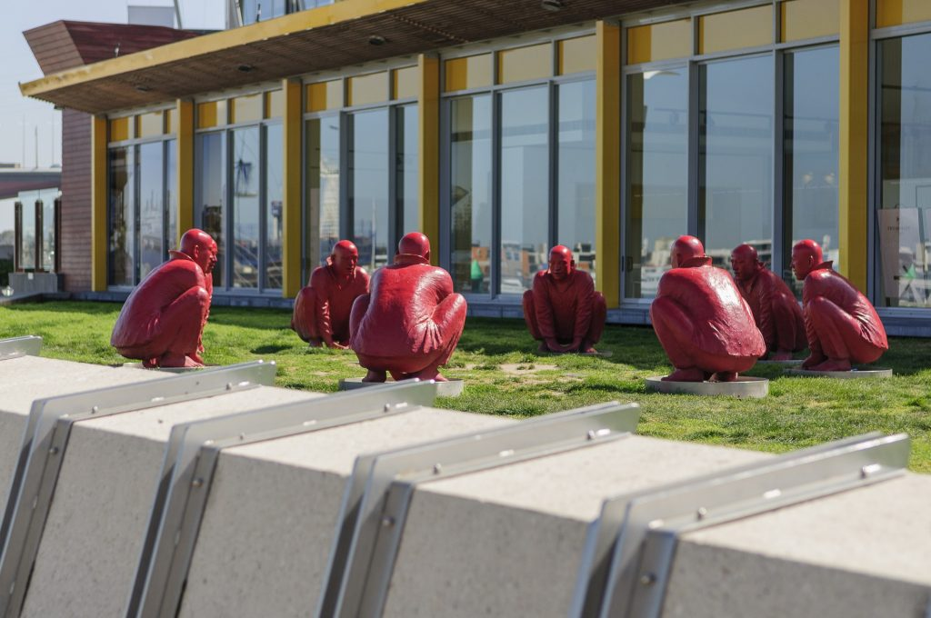
Meeting 1
Wang Shugang, 2009
painted bronze
NewQuay Promenade, Docklands
Purchased by MAB Corporation, 2013 City of Melbourne Art and Heritage Collection
Photo: Patrick Rodriguez

Nikki Lam is a Hong Kong born visual artist and independent curator based in Melbourne, Australia.

Nikki Lam – nikkilam.info
Meeting 1 – citycollection.melbourne.vic.gov.au/meeting-1
City Collection – citycollection.melbourne.vic.gov.au
Public Art and Memorials Map - citycollection.melbourne.vic.gov.au/public-art-and-memorials-map

