
Place over time: shifting ideas of place and the
City of Melbourne’s contemporary art collection
by Emily Bitto

I was living in Brisbane when I first read David Malouf’s work. There was – there still is – something remarkable in the experience of seeing one’s home town represented in the pages of a book; it’s almost as startling as if one had opened the pages and seen one’s own image unexpectedly printed inside. There, in Malouf’s Johnno and 12 Edmondstone Street, I encountered a litany of place names that were as familiar and, until then, unromantic as the names of my own family: Queen Street, St Lucia, Roma Street, Deception Bay, the Glasshouse Mountains. There were the mango trees that populated the hilly backyards of my suburb, the same trees that my housemates and I crept out at night to raid, plucking the fruit hanging close to our neighbours’ fences with a coathanger hook taped to a broom handle; the Moreton Bay figs that we picnicked under in Newfarm Park. There were the houses – the old ‘Queenslanders’ – weatherboard, up on stilts, and ‘on such easy terms with breezes, with the thick foliage they break into at window level, with the lives of possums and flying-foxes, that living in them … is like living in a reorganised forest’.

I lived in four or five such houses during my Brisbane years, and Malouf’s description evokes them precisely. And yet, it does more than that, and it was not only a thrill of recognition I felt back then, when I first read those still-beloved books, but something deeper and more profound, too. For me, at the age of 20 or 21, Malouf’s influence was of two kinds: one of which I continue to identify with today; the other of which I now see, on reflection, as somewhat embarrassing.

The first, less shameful, impact of reading Malouf’s work was that it made me see the place I was living in – really look at it – for the first time. Having Brisbane reflected back to me in this way deepened my awareness of the particularity of this place and the way it shaped its inhabitants, myself included. That word, shaped, is important, for Malouf believes that place shapes people as much as people shape place. In his words, Brisbane offers ‘something other’ than ‘the wide, dry landscapes of Southern Australia that we sometimes think of as “typical,”’ and ‘shapes in those who grow up there a different sensibility, a different cast of mind, creates a different sort of Australia’.

Brisbane had shaped me, but until then I had been unaware of, perhaps even resistant to, such shaping. I was born in Melbourne and, as I saw it, had been ‘dragged away’ against my will, at the age of 10, when my mother and stepfather had moved to Queensland. For this reason, I had been staunchly closed to the possibility of this place engendering a ‘different cast of mind’ in me. Reading Malouf not only helped me to recognise the ways in which, in those 10 or so intervening years, I had been altered by my reluctant new home, but to value and, yes, even to embrace, the ways it had shaped me. Brisbane began to engender an easier attitude in me: a relinquishing of the desire for order, control and certain ideas of beauty; an appreciation of the proximity to nature so vividly evoked in Malouf’s descriptions of its streets and houses; an embracing of the value of a more relaxed tenacity, of scrappiness, and even a certain degree of chaos.

And this brings me to the second impact of reading Malouf. Seeing Brisbane represented in a work of literature elevated its position in my mind, and increased its ‘cultural capital’. Though I am ashamed to admit it, in my teens and early 20s I was crippled by that most Australian of maladies: the cultural cringe. I suffered the same shame and snobbery that Malouf describes in 12 Edmondstone Street, when he observes wryly: ‘Brisbane was a one-storeyed weatherboard town … Weatherboard was too close to beginnings, to a dependence on what was merely local and near to hand rather than expensively imported. It was naïve, provincial, poverty-stricken – poor white. Real cities, as everyone knows, are made to last. They have foundations set firm in the earth.’

By the time I lived there, it was not all one-storey, but what was new was even more ghastly than what was old(-ish): the fake beach with dirty river view in the newly developed Southbank; the endless new apartment complexes, each with its own distinct and clashing ‘design feature’. I even thought the sunlight ‘tacky’ in Brisbane, the way it made everything seem primary coloured in its intensity compared to the more subtle, muted tones of cloudy Melbourne. I saw Melbourne as a more ‘European’ city, and in my young mind that was a synonym for ‘sophisticated’. As well as being ‘ugly’, Brisbane felt provincial and monocultural, cut off from and oblivious to the rest of the world to a greater degree than Melbourne.

Though I’m sad to say that I did not get there on my own, Malouf’s work redefined Brisbane, in my snobby eyes, as a place that held more interest than I had given it credit for – a place worthy of ‘literature’. This was no coincidence. In his 2000 Neustadt Lecture, Malouf says this about his aims in writing Johnno:

[Johnno] was about growing up in my hometown, Brisbane, a place that for some reason had never till then got itself into a book – or not anyway in a form that had brought it alive in people’s minds and stuck. I wanted to put it on the map; to make it, in all its particularity a place that would exist powerfully in the lives of readers in the same way that Dickens’s London does, or Dostoevsky’s Petersburg. That is, as a place fully imagined, since I had already grasped something paradoxical, which is that places become real in a reader’s mind not as embodiments of observation and fact but through invention, as imaginary places that bear the names of real ones, and if they are created with sufficient immediacy and glow, will in the end replace the real one; or perhaps I should say live as its more lively and convincing double.

A place fully imagined. To achieve this act of imaginative invention is, in Malouf’s view, one of the most important functions of art. In his Boyer Lectures, published in 1998 under the title, A Spirit of Play, Malouf states: ‘this business of making accessible the richness of the world we are in, of bringing density to ordinary, day-to-day living in a place, is the real work of culture’. So successful was Malouf’s project that I have heard Brisbane described with the adjective, Maloufian. Such is the power of cultural objects in the creation of ‘imaginary places’.

When I was invited to write this essay for the City of Melbourne’s Art and Heritage Collection, my mind turned back to Malouf and the role he played for me in understanding my complicated relationship to place, as well as my desire to become a writer myself. There is no doubt that Malouf’s writing was instrumental to my own; although it was Melbourne I wrote about in my own debut novel, The Strays, it was with Malouf’s words ringing in my ears. And though the Melbourne I depicted was in the past – the city and its undeveloped suburbs during the 1930s and early 40s – my aim, too, was ‘to make it, in all its particularity a place that would exist powerfully in the lives of readers’. Malouf gave me the confidence to look around me, rather than farther afield, for my subject matter, and for that I remain grateful.

And yet, it is now 20 years since Malouf’s Neustadt Lecture, and in the intervening years a lot has changed. When I re-read Malouf’s lecture now, its vantage point seems to be a location from which we may, collectively, have moved on. The cultural cringe that Malouf drew attention to in my own perspective, and that he owns himself, can perhaps no longer be assumed in the anticipated reader. In fact, Malouf’s anticipated reader, too, is implicitly assumed to be a descendant of British colonisers or, at farthest, European migrants to Australia. In A Spirit of Play, for example, Malouf reflects on the question of how, ‘in the face of all that Europe represents in terms of achievement and influence, we are to find a proper value, neither brashly above nor cringingly below its real one, for what belongs to the new world; for what is local but also recent, since part of what is “superstitious” in our valuation of Europe has to do with the reverential awe we may feel in the presence of mere age’.

The ‘we’ here implies a particular cultural background in the ‘Australian’ reader that can simply no longer be assumed, if indeed it could in 1998 when this was published. It is certainly not relevant to an Indigenous reader, nor to a recent (or even second-generation) migrant from, say, Vietnam or Iran. Furthermore, it is not only the implied homogeneity of Australian readership that is assumed here but also the sense of reverence for a more established culture ‘elsewhere’, which could in fact just as easily be located in Vietnam or Iran. In his essay ‘Living the Dream: The Contemporary Australian Artist Abroad’, Chris McAuliffe observes that while, historically, ‘the impediments to Australian artists working internationally were said to be the so called “tyranny of distance” (coined by Geoffrey Blainey in 1996) and “cultural cringe” (coined by A.A. Phillips in 1950)’, for contemporary Australian artists, these are widely regarded as ‘things of the past’. And in fact, in the current era of mass movement and migration, the idea of a deep or longstanding connection to a particular place is far from easily assumed, or even perhaps desirable. The ‘average’ contemporary Australian reader of Malouf’s work is just as likely to have been born outside Australia, and to bring to her reading a completely different set of experiences and struggles in terms of the necessary grappling with ideas of location and belonging that remains an essential part of the human condition.

What then, is the contemporary significance of seeing the place in which one lives represented in a work of cultural production? What is the significance for the contemporary artist of representing their ‘home’ or dwelling place within their work? What is the purpose of an ‘official’ collection that purports to represent a city such as Melbourne? These were some of the questions that surfaced, for me, as I began to examine and engage with the City of Melbourne’s contemporary art collection.

According to Raafat Ishak, an Egyptian-born Australian artist whose multi-layered, architectural, semi-abstract paintings feature in the collection, the specifics of place have had little relevance to the reception of his work as a contemporary international artist:

The fact that I am, at least technically, Australian, and engaging in an Australian dialogue, is mostly insignificant. By the nature of the word itself, international art is international, it has no specific location.

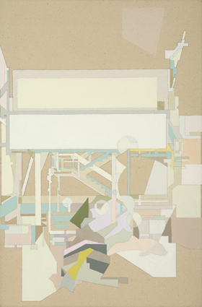
Raafat Ishak, Medication Valley, 2007, oil on canvas, 60 x 40 cm
Ishak tells me that his early attempts to ‘simulate’ into Melbourne were expressed via a dedicated endeavour to learn the layout and the character of the city. ‘My first instinct’, he says, ‘was to spend the very little money I had on the latest edition of Melways. A detailed map of Melbourne which I would carry with me, often wagging high school, to explore new parts of Melbourne that I was not familiar with.’ Yet he speaks now of this strategy as a ‘misunderstanding’, and resists the simplistic assessment of his work as ‘Melbourne-specific’, explaining, ‘I think my work can be localised to Melbourne, it can be considered specifically, it was made in Melbourne, and it was related to a specifically Melbourne experience. Having said that, I think this assessment is superficial at best.’ Ultimately, his focus is ‘not localised, it is generalised.’ Thus, in Ishak’s work, place specificity is largely incidental and the attempt to ‘simulate’ into Melbourne becomes symbolic of the experience of dislocation, migration and place-making on a universal, human level. Although he states that ‘place means a lot to [him]’, he is careful to explain:

I do not aim to ever make work that shouts out a ‘place’, specifies a monument, a location, a perceived mannerism, that would be propaganda which I have no interest in. The work comes out of personal experiences (place and people) but is presented as a generalised, hopefully all encompassing, expression of a state of being … If good enough, it should be relevant anywhere.

In this formulation, the particularity of place is unimportant, or at least subordinate to the larger global experience of ‘finding one’s own place’, and the representations of Melbourne that make up the contemporary collection might better be understood as explorations of urban experience, rather than Melbourne experience.

Louise Forthun, another artist whose work is represented in the City of Melbourne collection, also expresses, though with a somewhat different emphasis, the paradoxical specificity and generality that characterises her representations of Melbourne. Her work comprises multi-layer stencilled paintings of urban scenes: aerial grids, construction, skyscrapers, bridges. Initially, Forthun’s interest in representing Melbourne sprang from the ideological aim of resisting the pressure to paint traditional landscapes or ‘still lives and nudes’ that she felt in art school. ‘It was very 19th-century’, she tells me:
I’d never really liked Australian landscape painting or found that it had anything to do with me or my experience of life. So I sort-of set these little rules … I felt like I had to somehow, in my painting, represent my life: a girl, in the 20th century, then; living in the suburbs or the city. I sort-of aligned myself with Howard Arkley and John Brack and those people, as opposed to the Australian landscape … So that’s how I came to think about the city.

While her early work was therefore underpinned by a politics of the specific and personal – the desire to make art from what she saw around her – in another sense, Melbourne functions in her work as a way of exploring urban spaces and urban experience more broadly, and in this sense, as for Ishak, the particularity of Melbourne as setting or subject is secondary. ‘Cities are an endless source of information’, Forthun observes. ‘And they’re sort of like a stage for us to act out our lives on. For better or worse.’ From this perspective, it is perhaps irrelevant whether Forthun’s complex, layered forms are derived from Melbourne or from New York, Paris or Tokyo, all of which have also featured in her work. ‘[I’m] trying to make a screen to say that we don’t really know the city’, she says. ‘I guess that’s what I’m trying to say.’

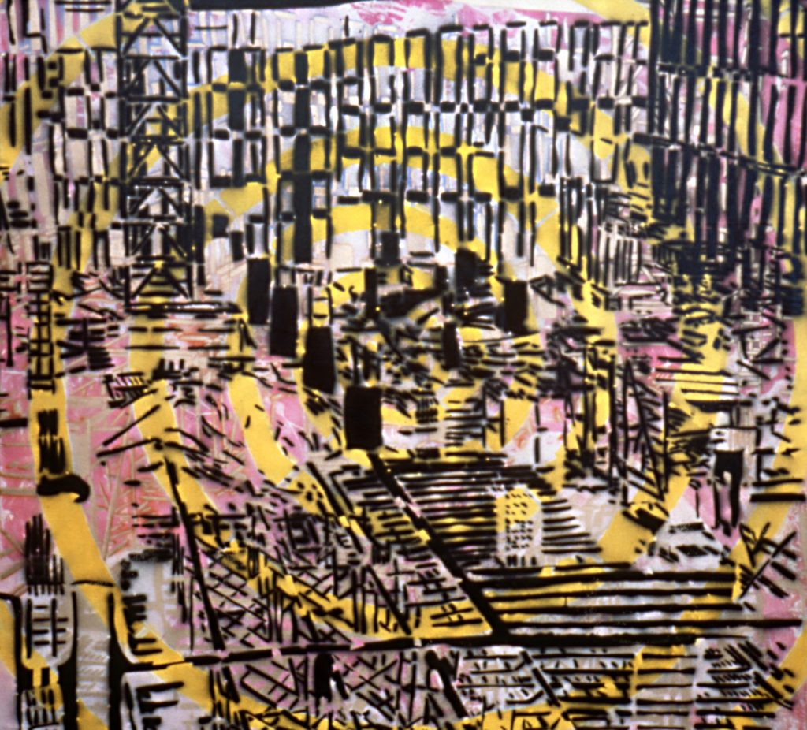
Louise Forthun, Black Construction Site on Yellow Spiral, 1991, oil on canvas, 203 x 203 cm

The ideological tension between the particular and the general, the local and the global, is a longstanding one, and fascinating in itself. Looking at the City of Melbourne’s contemporary art collection as a whole, this tension is evident, too. Of course, being a municipal collection, part of its function is to present an impression of the city consistent with the official ‘vision’ endorsed by Council. The Council’s acquisitions guidelines for contemporary indoor art state that new acquisitions ‘are expected to be displayable in Council’s buildings’ and should convey to viewers ‘an image of Council and the city it serves as a vibrant, diverse and creative global city that respects its heritage, is determined to reduce its ecological footprint and considers its people its greatest asset’.

One might assume that these strategic guidelines could perhaps compromise the potential of the collection to offer a complex, nuanced (not to mention critical) representation of Melbourne. However, surveying the collection, it is apparent that the works acquired over the past decade and a half, since the establishment of an acquisitions panel that includes four independent art experts, present a complex vision of the particularity of this city, and explore the tensions between the local and the global that Ishak and Forthun allude to. Whereas many of the earlier works in the collection feature fairly conventional representational images of significant or recognisable buildings or vistas (the Yarra River, Flinders Street Station, trams and heritage buildings), as well as many depictions of construction and various kinds of work and labour (consistent with the image of Melbourne as a ‘boom’ city promoted in the 1980s), recent acquisitions offer a more ambivalent view of the city, as a contested space. While there are still the ‘tourist-friendly’ evocations of laneway culture, the vibrant music scene, football and other attractions, the collection now also holds a significant number of works that explore the complexities of consumer capitalism, surveillance culture, Indigenous and migrant experience, protest, and the loss of ecological diversity and habitats for wildlife.

These developments in the collection also mirror shifts in the politics of representation over the past decades, since the time of Malouf’s Neustadt Lecture. As Raafat Ishak has observed, it may now be less of a concern for contemporary Australian artists to represent the specifics of place than to investigate the more general themes of ‘place-making’ and ‘belonging’, or, in the case of the City of Melbourne collection, ‘urban experience’. In fact, only one of the four acquisition criteria listed on the collection’s website – ‘representations of Melbourne; the city as a universal theme; the city and environmental themes; and works by urban Indigenous artists’ – requires Melbourne-specific content.

How, then, might the collection – in its individual works and as a whole – contribute to the making of Melbourne as an ‘imaginary city’, in Malouf’s sense? Or is Malouf’s project no longer relevant in the current historical moment? When examined as a whole, the contemporary art collection presents a vision of Melbourne that is characterised, more than anything, by flux. As Chris McAuliffe observes in his essay ‘The Art of Living in a City’, ‘artists reinvent the city with each new image, and ‘it might even be said that contemporary Melbourne is not simply a material place but a rolling debate on its own definition, one that outpaces not only planners and policy-makers but also artists’. It is precisely this ever-evolving process of self-definition that the collection captures in a way that often eludes a single artist or work. It is, therefore, fascinating to contemplate the collection as documenting the very shifts in the politics of place and representation that I have been considering here.

In the course of researching this essay, my discussions with Raafat Ishak and Louise Forthun, and my engagement with the collection itself, have caused me to question and re-evaluate my own ideas about the representation of place, as well as my reasons for wanting to engage with place in my own creative work. While the reasons for and politics of engaging with the specificity of place in works of cultural production may shift substantially over time, the attempt to chart and understand these shifts is, in itself, a productive undertaking. One thing that can be said with certainty is that for the contemporary Australian artist – whether of Indigenous, white colonial, or more recent migrant background – the relationship to place is complex and fraught.

In the opening pages of her seminal monograph The Lure of the Local, Lucy Lippard writes:

I have been lured to the subject of the local by its absence or rather by the absence of value attached to specific place in contemporary cultural life, in the ‘art world,’ and in postmodern paradoxes and paradigms.

Implicit in this statement is a criticism of the disavowal of place specificity, or the local, that Ishak seems to be making in his statements above, which in turn is a rejection of what might be seen as parochialism and cultural cringe in Malouf’s determination to ‘put Brisbane on the map’. Though Lippard and Malouf might appear to be advocating for the same thing, their reasons are different, as are the reasons for Ishak’s and Forthun’s assertion that their work both is, and is not, Melbourne specific. In part at least, Malouf’s aim is to offer non-Indigenous Australians a way of developing a kind of spiritual relationship with this place, of ‘taking [it] into our consciousness and giving it a second life there so that we possess the world we inhabit imaginatively as well as in fact’.

For Lippard, ‘place’ is instead contrasted with the idea of ‘no place’, which is shorthand for the kinds of homogenous spaces that result from the hegemony of capitalism, in which the most familiar landscape for a large number of the world’s residents is the indistinguishable metropolis or shopping mall. In Lippard’s words:

the word place has psychological echoes as well as social ramifications. ‘Someplace’ is what we are looking for. ‘No place’ is where these elements are unknown or invisible, but in fact every place has them, although some are being buried beneath the asphalt of the monoculture, the ‘geography of nowhere’.

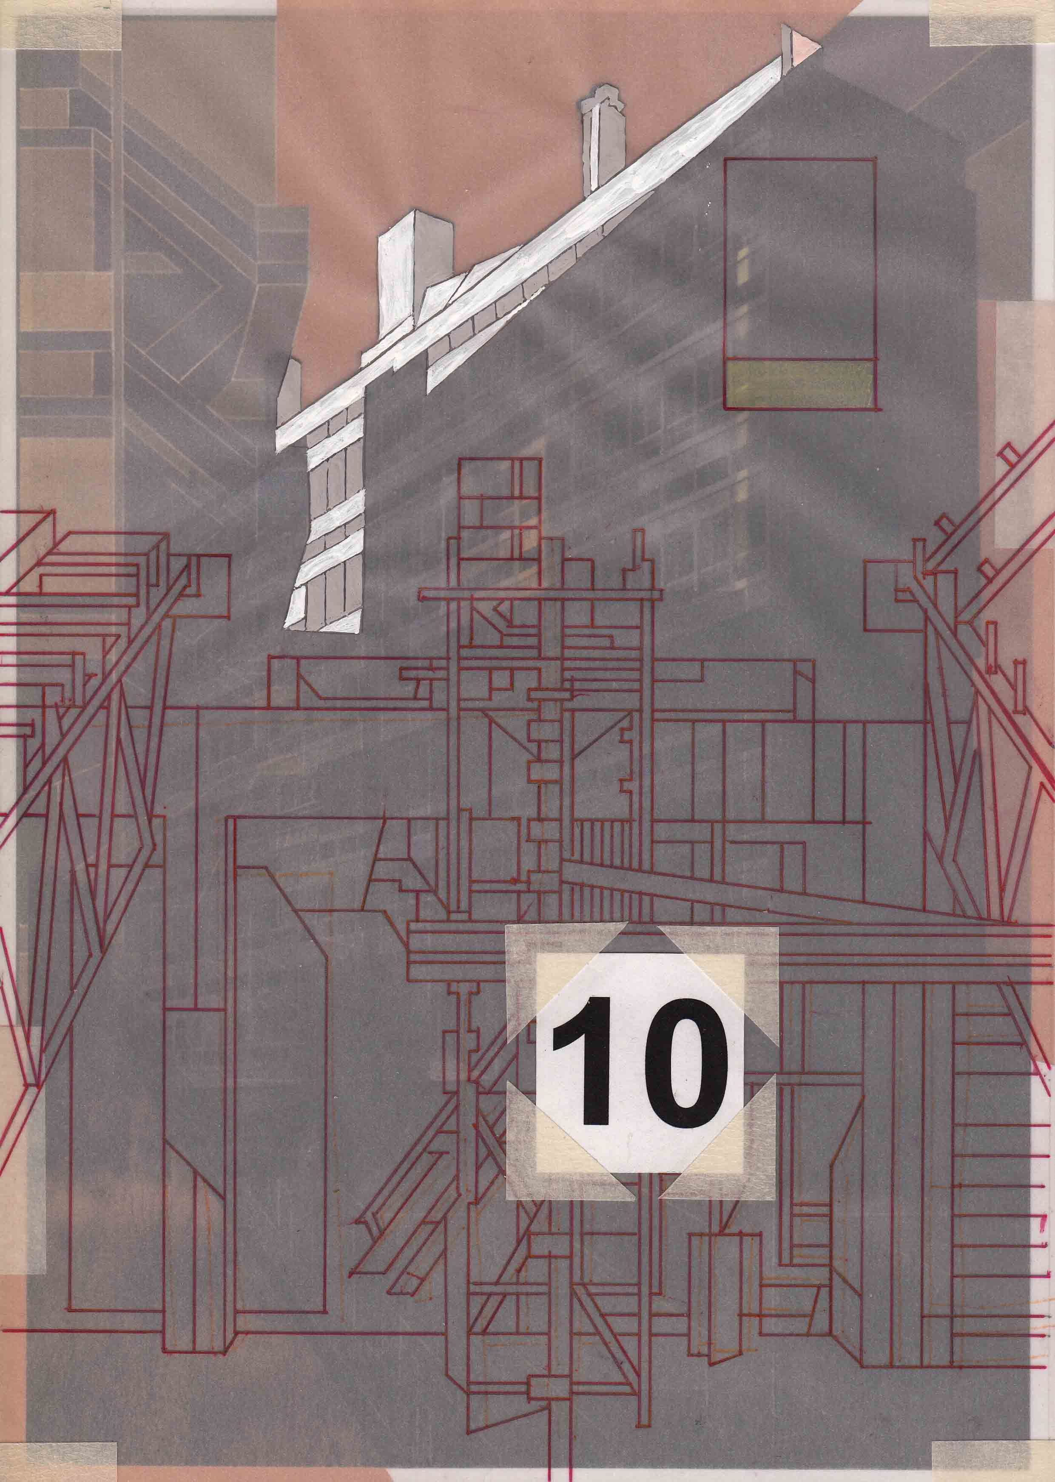
Raafat Ishak, Graduate Research and Withdrawal #10, 2014, mixed media on paper and glass, 32.5 x 23.5 cm (framed)

And yet, for the contemporary city-dweller, there may also be positive connotations of mobility and democracy in such ‘non-places’. Further, there may also be a genuine sense of belonging attached to these spaces, and indeed a lack of belonging and identification associated with the kinds of places against which they are opposed (places which, through this opposition, are implied as more ‘real’ or ‘authentic’). Interestingly, both Forthun and Ishak explicitly describe their lack of identification with the Australian landscape, meaning the vast areas of Australia that are not composed of towns or cities. As quoted above, Forthun’s practice developed in resistance to what she saw as a pressure to identify with and represent these landscapes, and Ishak similarly states:

if there is anything un-Australian about me, it is my lack of interest in the landscape, the country side, the outer margins, because I guess deep down, I feel like, as a contemporary population, we are on the periphery … waiting to be sent back to where we came from. The middle does not belong to me, even if ‘my’ government has jurisdiction over it.

In this formulation, too, the kind of imaginative ‘possession’ of place advocated by Malouf, and even, to a certain extent, by Lippard, might be seen in the colonial contexts of both Australia and America, as a further act of colonial appropriation, or at the very least as highly complex in ethical terms.

Yet another angle from which to approach the contemporary negotiation of ideas of place is with an emphasis on ecology and the threat to the non-human world represented by the human destruction of natural environments. The American poet, essayist and environmental activist Gary Snyder proposes a ‘bioregional’ approach to place, as a means to foster connection and care, and ultimately to avoid destruction of the natural world. From a bioregional perspective, categories and boundaries based on ‘arbitrary’ concepts of ‘nations, states, and countries’ are better substituted for regions defined by such factors as ‘biota, watersheds, landforms, and elevation’. Snyder explains:
The presence of [a particular] tree signifies a rainfall and a temperature range and will indicate what your agriculture might be, how steep the pitch of your roof, what raincoats you’d need. You don’t have to know such details to get by in the modern cities of Portland or Bellingham. But if you do know what is taught by plants and weather, you are in on the gossip and can truly feel more at home.

However, the reason for fostering such bioregional belonging is not merely the aim of feeling ‘more at home’. Snyder states that, ‘with this kind of consciousness people turn up at hearings and in front of trucks and bulldozers to defend the land or trees. Showing solidarity with a region! What an odd idea at first’.

In the current historical moment, it may ultimately be this environmental perspective that offers the most compelling reason for the contemporary artist to engage with the specifics of place. While this ‘bioregional’ knowledge may not be easy to come by for the contemporary Melbourne artist, surely the ethics of care and responsibility that bioregionalism espouses are worth aiming for. In Australia, the most obvious and under-utilised source of such knowledge lies in Indigenous culture. Interestingly, Raafat Ishak recalls, ‘one of the most personally surprising revelations when I migrated to Melbourne from Cairo in 1982 was how much the idea of place mattered in indigenous culture’. At the time, Ishak says, he took this ‘as a given … not really thinking about indigenous culture and what we know of its struggles and instead, understanding its weight as one worthy of considering, when determining how to live in a new place’.

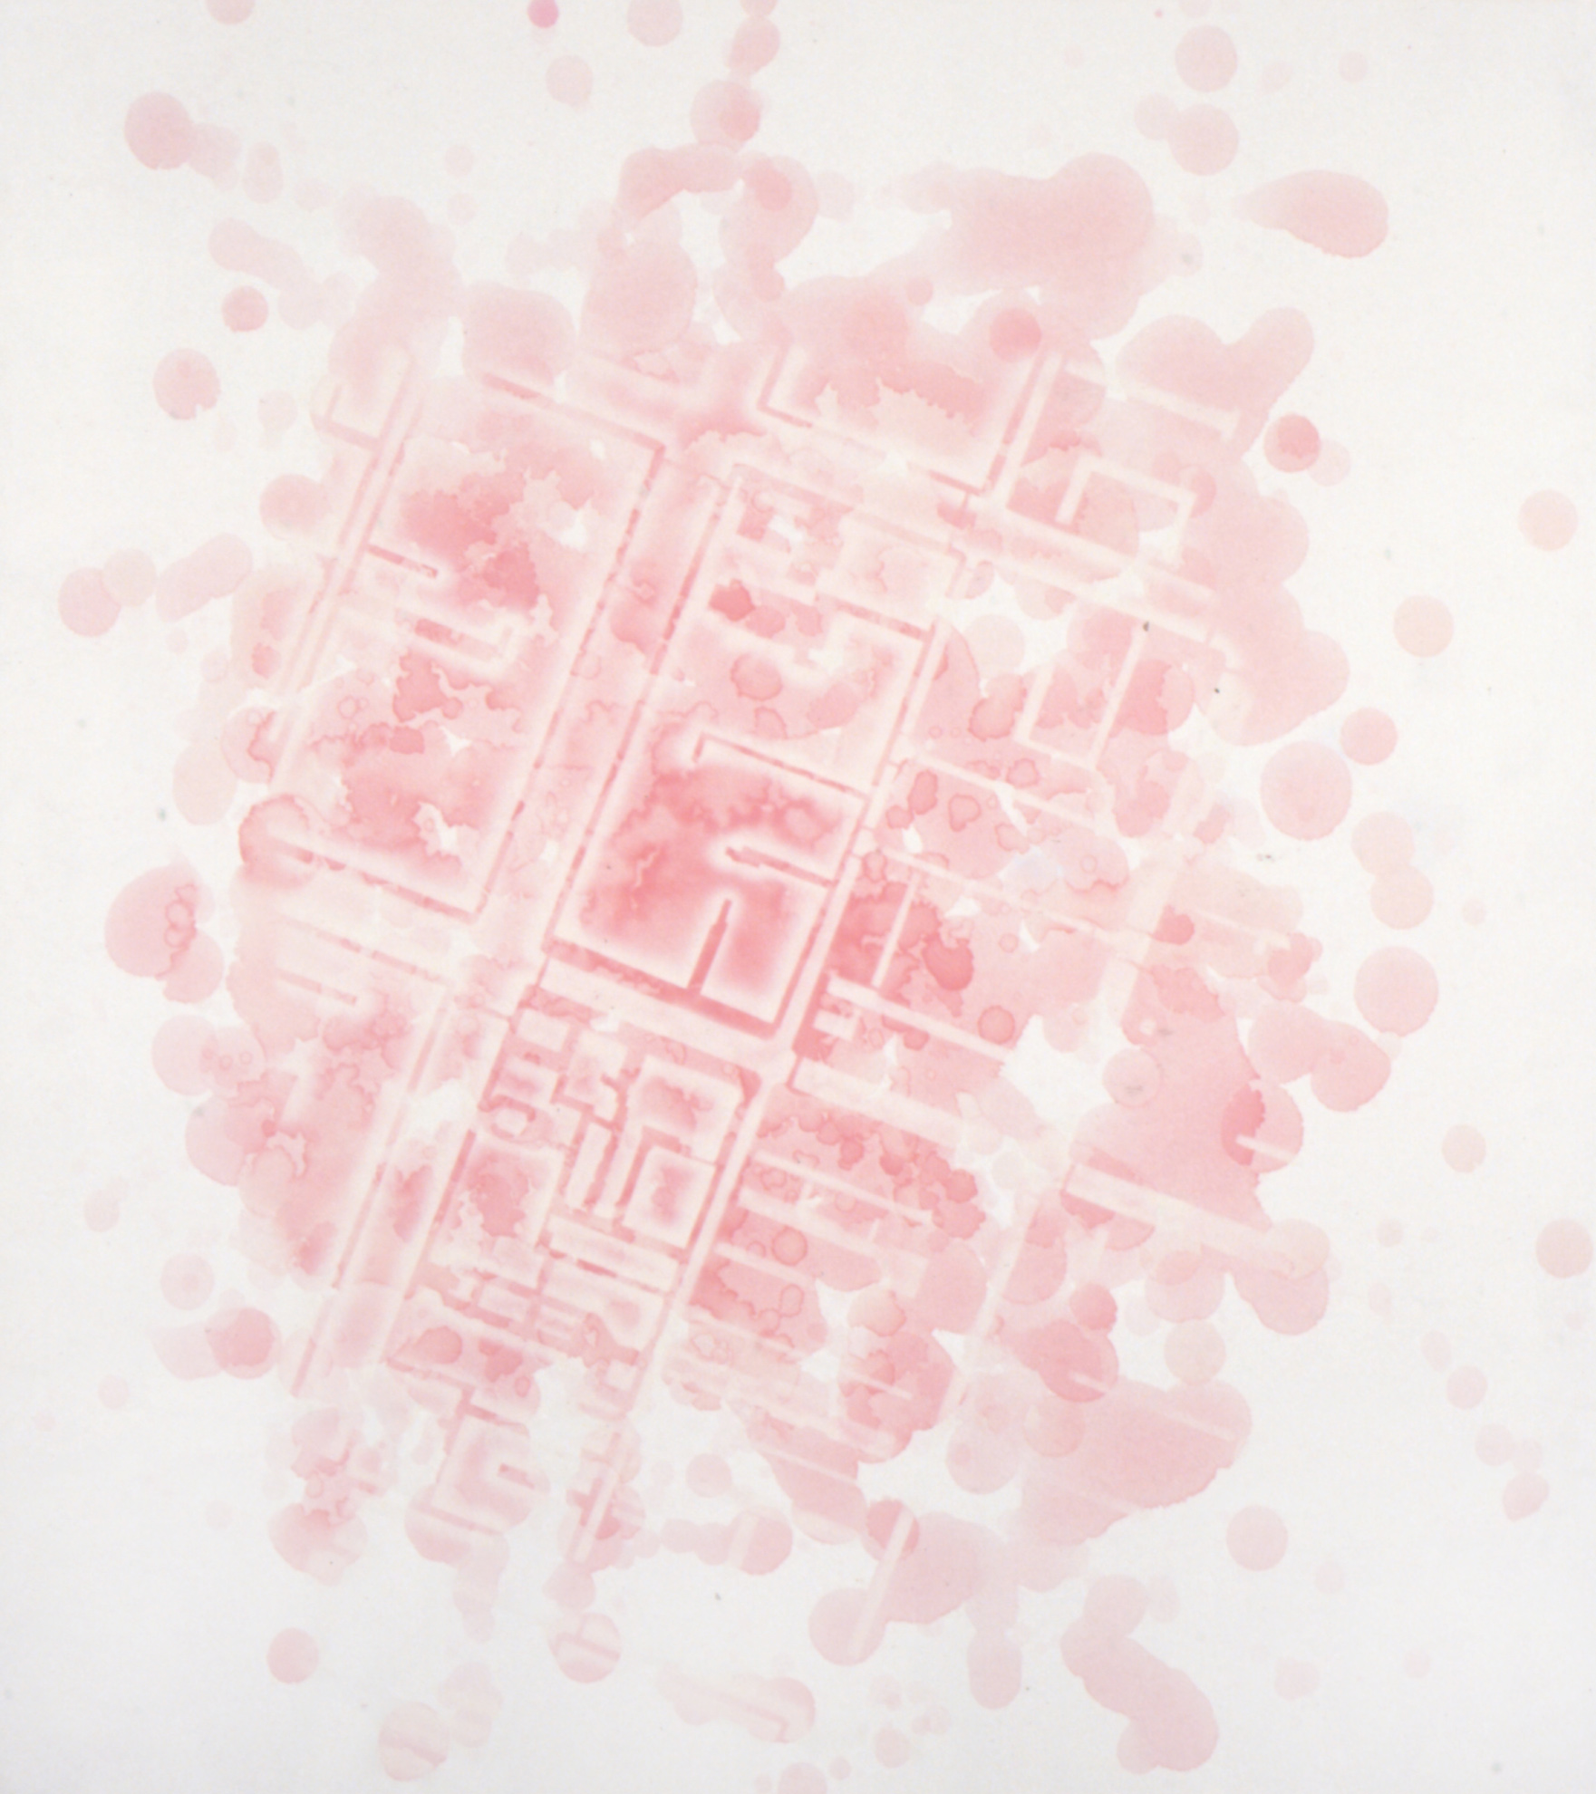
Louise Forthun, Pink, 2006, oil on board, 100 x 90 cm

Something that stands out in both Ishak’s and Forthun’s work, and also resonates with a bioregional conception of place, is the idea of place as a palimpsest, both materially and temporally. It is also something that I attempted to capture in my depiction of a past Melbourne in The Strays, for every representation of place is also a representation of time. And as do places themselves, our relationships to the ideas and ethics of place-making shift over time, as I hope has been evident in this discussion. This flux is central to the way in which the City of Melbourne’s contemporary art collection represents place. It is tempting to conclude that the defining feature of place-relations for the contemporary artist is its vexed and conflicted nature. However, Ishak points out that the conflicted, paradoxical nature of the contemporary engagement with place is, in fact, fundamentally productive. For this reason, his statement makes a fitting final word on the subject:

Finding my own place in a place that I did not grow up in has been a conflicted pursuit. But that is what has driven my work, that very contradiction, yet similarity between the primary concerns of indigenous culture and settler culture, driving for the same thing but with different intentions and manifestations. I think this position that I (and I am sure many more artists) find myself in is not problematic, it is generative, almost utopic.

David Malouf, 12 Edmondstone Street, Vintage, London, 1999, pp. 11–12.
David Malouf, ‘A First Place: The Mapping of a World’, in James Tulip (ed.), David Malouf: Johnno, Short Stories, Poems, Essays and Interview, University of Queensland Press, St Lucia, 1990, p. 263.
Malouf, 12 Edmondstone Street, pp. 5–11.
David Malouf, ‘A Writing Life: The 2000 Neustadt Lecture’, World Literature Today, vol.74. no. 4, 2000, pp. 701–02.
David Malouf, A Spirit of Play: The Making of Australian Consciousness, ABC Books, Sydney, 1998, p. 35.
Malouf, A Spirit of Play, pp. 25–26.
Chris McAuliffe, ‘Living the Dream: The Contemporary Australian Artist Abroad’, Meanjin, vol. 71, no. 3, 2012, pp 56–63.
Raafat Ishak, email interview with the author, 26 May 2020; quotes from the artist throughout the essay are drawn from this interview.
Louise Forthun, personal interview with the author, 1 June 2020; quotes from the artist throughout the essay are drawn from this interview.
‘Acquisitions Sub-Panel Guidelines (Contemporary Indoor Art)’, City of Melbourne, 2016.
Chris McAuliffe, ‘The Art of Living in a City: Contemporary Art in the City of Melbourne Collection’, City of Melbourne, p. 4, online at: citycollection.melbourne.vic.gov.au/essays.
Chris McAuliffe, ‘The Art of Living in a City’, p. 3.
Lucy Lippard, The Lure of the Local: Senses of Place in a Multicentered Society, The New Press, New York, 1997, p. 5.
Malouf, A Spirit of Play, p. 35.
Lippard, The Lure of the Local, p. 9.
Gary Snyder, The Practice of the Wild, North Point, New York, 1990, p. 37.
Snyder, The Practice of the Wild, p. 38.
Snyder, The Practice of the Wild, p. 41.
A bioregional awareness quiz poses such questions as: ‘What primary geological events or processes that shaped the land where you live?’, ‘What was the vegetation type in this area prior to settler colonization? and ‘From what direction do winter storms come in your region?’. See Tina Fields, ‘Bioregional Awareness Quiz’, 18 June 2020, online at: indigenize.wordpress.com/2013/03/21/bioregional-quiz.

